D4.3

Case studies on 6 pilot actions with public procurers using Topten specifications

February 2014

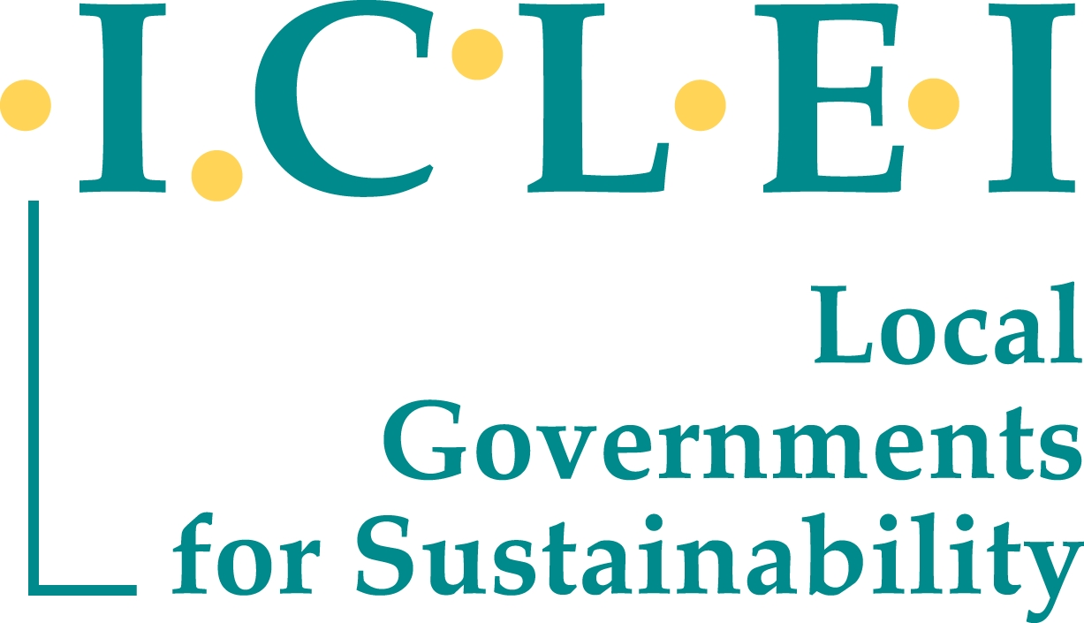

The Project in brief
Topten is part of the international Euro-Topten Max initiative supported by the European programme Intelligent Energy Europe and several national institutions (energy agencies, WWF, consumer associations, research institutes). On global level, Topten is coordinated by TIG, the Topten International Group. This association promotes to the Topten Charter, TIG statutes and Rules of Procedure (www.topten.eu).
Topten is a service that supports the market for energy efficient products. It aims at making energy efficient products the first choice for consumers and professional buyers, by offering them a user-friendly tool for product comparison and selection. The key element is an online information platform for consumers and professional buyers presenting the most energy efficient appliances currently available in various product categories, including household appliances, office equipment, consumer electronics, lighting and cars. Information on energy consumption and performance of products as well as several other characteristics (i.e. brand, model, prize) is provided. Product data is based on labels and standardized declarations as well as tests from professional testing institutions. The service is independent of manufacturers and retailers.
Case studies on pilot actions with public procurers using Topten specifications
The work programme planned for 6 case studies on pilot actions in which public procurers would use the Topten selection criteria in a tendering process. However, it was complex to identify procurers and to fit into already planned procurement operations. Therefore, ICLEI and partners undertook many activities to publicise the Topten project and the Topten selection criteria. Partners have then identified cooperation they were working on, and good practices that had already taken place in terms of tendering of highly energy efficient products, and of which the criteria was at least partially of a Topten standard. ICLEI with the help of the national partners, managed to identify and develop six Topten case studies to replace the pilot actions (on-line at http://www.topten.eu/professional.html). These are presented in the following pages.

Consortium
The project is co-ordinated by the Agence de l’Environnement et de la Maitrise de l’Energie (ADEME). The other 19 project partners are:
 | Austria | Austrian Energy Agency (AEA), Vienna, www.topprodukte.at
 | Belgium | Bond Beter Leefmilieu BBL, Brussels, www.topten.be
 | Croatia | North-west Croatia Regional Energy Agency REGEA
 | Czech Republic | The Energy Efficiency Center (SEVEn), Prague, www.uspornespotrebice.cz
 | Finland | Motiva, Helsinki, www.topten-suomi.fi
 | France | Guide topten, Paris, www.guidetopten.fr,
 | Germany | Öko-Institut, www.ecotopten.de, Wuppertal Institute
 | Greece | WWF Greece, www.ecotopten.gr
 | Italy | WWF Italy, Rome, www.eurotopten.it
 | Lithuania | Lithuanian national consumer federation
 | Luxembourg | Ecological Center Luxembourg. www.oekotopten.lu
 | Norway | Norwegian Society for the Conervation of Nature / www.besteprodukter.no
 | Poland | Polish Foundation for Energy Efficiency (FEWE), Katowice, www.topten.info.pl
 | Portugal | Quercus - ANCN, Lisbon, www.topten.pt
 | Romania | Energy Research and Modernising Institute ICEMENERG
 | Spain | WWF Spain, Asociación para la defensa de la naturaleza (ADENA), www.eurotopten.es
 | Sweden | Naturskyddsföreningen, www.toptensverige.se
 | United Kingdom | Keep Britain Tidy
Contact
Therese Kreitz (project leader)
500, routes des Lucioles
F-06560 Valbonne
France
+33(0)493957984
therese.kreitz@ademe.fr
Sophie Attali  20 place de la Chapelle  75018  Paris  +331 8394 8209  sophie.attali@topten.info | Eric Bush  Rebweg 4  7012 Felsberg  Switzerland  +41 81 252 63 64  info@topten.info | Peter De Franceschi  ICLEI  Av. de Tervuren, 35 / 1040 Bruxelles Belgium  t+32 (0)2 735 28 50  peter.defranceschi@iclei.org

Topten Criteria in Public Procurement

Exemplary green power supply for the Consumer Assistance Centre of NRW
Case study 1

Buying Organisation

Consumer Assistance Centre of North Rhine-Westphalia (’Verbraucherzentrale Nordrhein-Westphalen’), Germany

Offers advocacy, consultancy and comprehensive assistance to consumers in NRW with consumer rights, energy bills etc.

Annual budget: 35 Mio EUR (through public funding, donations, projects etc.).

Website: www.vergabe.nrw.de

Procurement Background
Main drivers for the procurement of energy efficient products
- Contribution to climate targets by achieving CO₂ reduction through purchasing electricity from renewable energy sources
- Germany has a strong policy (Energy Transition, or ‘Energiewende’) and legislation (The German Renewable Energy Act or ‘EEG’ l) on the promotion of renewable energy sources
- Support from EcoTopTen , the national Euro Topten Max website and online database for Germany.

Main features of the tender
- Subject matter: 100% renewable power supply to the administrative office and 46 branch offices of Verbraucherzentrale NRW
- Electricity demand: Approx. 500 000 kWh (2012)
- Period: 24 months (01.10.2013 - 30.09.2015)
- Value: between 210 000 and 250 000 EUR
- Award criteria: lowest price
- Variants not admitted

Success factors
- Collaboration with the German Öko-Institut Freiburg, who developed EcoTopTen, provided the basis for the minimum criteria for electricity from renewable energy sources.
- Vast offer on the market: Germany, southern Germany in particular, has a vast choice of suppliers and producers of renewable energy.

Topten Criteria

Technical specifications

The technical specifications for the supply of electricity from 100% renewable energy sources explicitly referred to the environmental minimum criteria according to the EcoTopTen criteria for electricity (as of March 2013) as defined by the Öko-Institut eV Freiburg. Particular reference was made to Part 3 ‘Ecology’ and the ‘Environmental minimum criteria for EcoTopTen power products’

Regarding the selection of green power products by the ’Verbraucherzentrale NRW’, the following bids can be taken into consideration:

Green power supply offers that are already listed on current EcoTopTen lists for electricity from renewable energy sources;

Nationwide bids

Offers that provide appropriate evidence that the green electricity supply is in compliance with the environmental minimum standards according to the current EcoTopTen criteria.

Proof of compliance with the minimum criteria for green power supply is an independent and competent expertise according to the requirements set out in EcoTopTen (EcoTopTen power criteria 2013 p. 10) and has to be submitted unsolicited at the submission of the bid.

Additional Criteria

Retail as well as fund models will be taken into consideration. The respective requirements can also be found in the EcoTopTen criteria catalogue.

Differing bids (from EcoTopTen catalogue) are only admissible if the supplied power originates from renewable energy sources and is not based on ‘system power’.

Topten Criteria in Public Procurement

Finnish Foreign Service includes Topten criteria in Environmental Programme
Case study 2

Buying Organisation

The Ministry for Foreign Affairs within the Finnish Government is responsible for preparing and implementing the government's foreign and security policy.

It promotes Finland's commercial and economic interests, takes responsibility for development policy and development cooperation, takes care of public diplomacy and develops international and EU law on human rights.

It employs approximately 1,600 people and maintains 97 overseas offices housing foreign missions.

Annual budget for the administrative branch (2015) 1.190 Mio EUR

Finnish Foreign Service: Environmental Programme 2013-2020

Policy Background: Driving the procurement of energy efficient products
- One of the Finnish Government’s objectives is to be the world’s leading Clean-tech country. Public procurement is one of the means of achieving this.
- In April 2009, it signed a resolution that by 2015, environmental perspectives must be considered in all acquisitions made by Central Government.
- The Finnish Foreign Service developed an Environmental Programme as an instrument to help contribute towards these commitments.

The Environmental Programme (2013 – 2020)
- The Environmental Programme acts as a handbook on environmental issues for the departments, units, missions and personnel of the Ministry of Foreign Affairs.
- The Environmental Programme covers a variety of impact areas such as travel, estates, waste and procurement.
- One of the overarching priority objectives, due to its high level of impact, is increasing the energy efficiency of all technical equipment.

Success factors
- Categories of spend including copiers, multifunctional devices (MFDs), printers, faxes, refrigerators, freezers, dishwashers and washing machines specifically refer to Topten criteria as part of the specification goals.

Topten Criteria

Copiers, MFDs, printers and faxes

Technical specifications

Double-sided (duplex) printing capability

The devices must fulfil the criteria of the latest Energy Star standard in terms of power consumption.

(In EU countries) the more energy efficient Topten criteria on power consumption can also be set as the minimum requirement.

Award criteria

Power consumption smaller than that set by the latest Energy Star Standard, e.g. meeting or surpassing the energy efficiency index set.

Refrigerators, freezers, dishwashers and washing machines

Technical specification

Topten criteria can be applied

Award criteria

Energy efficiency category better than the minimum specification of A++ for refrigerators and freezers (i.e. meeting the Topten criteria of A+++)

Computer monitors

Technical specification

Most fulfil the criteria of the latest Energy Star standard in terms of power consumption

Award criteria

Less power consumption that that set under the technical specifications

Additional Criteria

Technical specifications

The backlight of LCD monitors must contain no mercury

Warrantee 2 years minimum for white goods

Award criteria

Warrantee more than 2 years for white goods

For computer monitors, copiers, MFDs, printers, faxes, refrigerators, freezers, dishwashers and washing machines, the following may be used to evaluate bidders:

The amount of the product/ unit/ device that can be recycled

The product’s life cycle as specified by the manufacturer

The length of time the manufacturer guarantees servicing and the availability of spare parts

Existence of recycling system for each product (including screens for computer monitors)

Implementation
- Euro Topten Max partner, Motiva, advised the Ministry on the use of Topten criteria to ensure that they procure the most energy efficient products to bring about both environmental and economic benefits.
- The Ministry recognises that the procurement of energy efficient products may imply higher acquisition costs, but these are considered as a part of overall life cycle costs (LCC) as standard.
- The Environmental Programme comes complete with specific goals and indicators, which are being monitored and re-specified annually.
“The Topten Pro website has offered useful ideas about efficiency criteria to be used on tendering processes. It has considerably eased up our work.”
Asmo kemppainen, Ministry of Foreign Affairs

Topten Criteria in Public Procurement

The district of Göttingen goes for EcoTopTen green power
Case study 3

Buying Organisation

Göttingen is a district in Lower Saxony, Germany.

The population accounts for around 250,000 people living within 1,117 km²

Website: www.landkreis-goettingen.de

Procurement Background
Main tender features
- Subject matter: 100% renewable power supply to public facilities of the Göttingen District
- Electricity demand: 51 public assets including schools, sports and administrative facilities;
- Period: 24 months (2014-2015)
- Award criteria: most economically advantageous tender (MEAT)

Main driver for the procurement of energy efficient products
- Added value for the region by creating demand for 100% renewable energy generation and supply
- Contribution to climate targets by achieving CO₂- reductions through purchasing electricity from renewable instead of fossil fuel-derived energy sources

Success factors
- EcoTopTen, the national Euro Topten Max website and online database for Germany, provided the base for the minimum criteria for electricity from renewable energy sources.
- The German Öko-Institut Freiburg rated the winning bidder, HarzEnergie, as a provider of a top environmental product for its green electricity known as ‘NaturWatt Strom’, in its EcoTopTen list. This list includes only providers of products that ensure that the energy production in Europe will become more environmentally friendly and that support new green power plants

Topten Criteria
Technical specifications

The technical specifications for the supply of electricity from 100% renewable energy sources explicitly referred to the environmental minimum criteria according to the EcoTopTen criteria for electricity (as of March 2013) as defined by the Öko-Institut eV Freiburg;

Proof of compliance with the minimum criteria for green power supply is an independent and competent expertise according to the requirements set out in EcoTopTen and has to be submitted unsolicited at the submission of the bid.

Additional Criteria

Retail as well as fond models will be taken into consideration. The respective requirements can also be found in the EcoTopTen criteria catalogue.

Differing bids (from EcoTopTen catalogue) are only admissible if the supplied power originates from renewable energy sources and is not based on system power.

Results
The winning bid “HarzEnergie NaturWatt Strom” is composed of 100% wind, water and solar power. TÜV Nord monitors the origin of the electricity annually, alongside its contribution to the promotion of new renewable energy production (required by EcoTopTen criteria). Moreover, it guarantees transparency throughout the supply chain and engages in the implementation of new renewable energy projects.

"We were able to make a convincing offer both in content and economic terms. Choosing a local, regional utility ensures also a large portion of the regional added value remains at local level."

Andreas Grannemann, HarzEnergie

Topten Criteria in Public Procurement

The GREEN IT PROGRAMME

Case study 4

Buying Organisation

Brussels Capital Region is comprised of 19 municipalities with a total population of around 1.2 million inhabitants within 162 km²

The publicly-owned CIRB (Centre d’Informatique pour la Région Bruxelloise) coordinates and promotes the use of IT by Brussels’ local and regional public authorities including administrative bodies, schools, hospitals and private citizens

CIRB functions as central purchasing body and through the GREEN IT programme it aims to be a leader on sustainable IT procurement.

Website: http://cirb.brussels/

Procurement Background
Main drivers and enablers for the procurement of energy efficient products
- European Commission “Buying Green” Handbook.
- Brussels Capital Region Government Memorandum on the insertion of environmental and sustainable development criteria into public procurement of supplies and services.
- Availability of Ecolabels, Energy Star in particular.

Main features of the GREEN IT Programme
- Procurement criteria aim to:
  - reduce energy consumption
  - reduce the noise level of the appliances
  - reduce the number of appliances
  - encourage the recycling of packaging and consumption goods
- Total Cost of Ownership (TCO) focus:
  - Including acquisition, usage, maintenance, disposal
  - Inviting sub-suppliers to integrate LCC considerations in the prices with regards to consumption goods (e.g. cartridges) and electricity consumption for the whole life of the product

Topten and other criteria

Criteria used as part of the GREEN IT Programme relate include the following:

Energy consumption

Reference to latest version of the Energy Star criteria;

Obligation to provide data on exact energy consumption as well as guidance energy-efficient usage

Guarantee

Minimum 3 years for material components;

Maintenance charges to be paid by supplier

Consumables

Number of printable pages in standard and ECO mode;

Availability of spare parts

Waste minimisation

Recycled packaging;

Recycling procedure for used equipment and faulty spare parts

Ecolabels

Appliances must meet criteria under the ROHS directive and EPEAT

Example tender released under the GREEN IT Programme
- Subject matter: IT appliances
- Period: 24 months, starting 2014
- Value: 5 million euro per year
- Award criteria: weighting of award criteria; sustainability criteria (Green IT) weighted at 7% and divided into sub-criteria. Other criteria relevant to the weighting: devices sound level, consistency with EPEAT criteria, durability of lamps, equipment and packaging recycling, ozone, benzene, dust emission levels
Results
- 19 bids were received

Despite the integration of environmental criteria and the superior technical performance obtained, all products except for the servers resulted in reduced costs

Success factors
- Pre-tendering market analysis
- Integration of the notion of “total ownership cost” in the tender.
- Targeted internal (public administrations) and external (market) communication

Topten Criteria in the Procurement of Office Equipment

Smart Offices – Literacy and Energy Management in Portugal  Case study 6 |  | © Image courtesy of hywards at FreeDigitalPhotos.net

Project “Smart Offices / Energy Off” - Literacy and energy management

This national project provides capacity building in energy auditing to help 850 Portuguese SMEs improve the energy efficiency in offices using, amongst other tools, the Portuguese Topten procurement guidelines.

Website: http://www.energyoff.pt (online, to be updated February 2015)

Duration of project: January 2014 - December 2015

Duration of website tool: It will be active at least for five years

Project Overview
Portuguese project partners:
- The project is coordinated by the Network of Energy and Environment Agencies (RNAE) under the Plan for Promoting Efficiency in Consumption (PPEC)
- Partners include the Topten partner ‘Quercus - Associação Nacional de Conservação da Natureza’ and INTELI
- The Energy Services Regulatory Entity (ERSE) is financing the project

Objectives
- The provision of training and information on diagnosis i.e. benchmarking energy consumption and energy management. The performance of office buildings (located in the Portuguese mainland and islands) is evaluated through an online energy audit that forms part of this toolkit.
- To encourage the use of this toolkit by 850 small and medium enterprises (SMEs) that procure office equipment

Activities
- The training is provided in the form of digital content included in the diagnosis toolkit, a video tutorial and a webinar, available as part of the project website
- Initially, users are required to complete an online questionnaire, inputting relevant data and listing current office equipment, energy consumption and staff behaviour, plus existing contracts for the provision of energy related products and services.
- The target ambition level must then been defined, performance indicators set and the means of implementing the action plan established.
- According to the above results, various tools are provided to the ‘office user’ e.g. staff training materials and guidance on the purchase of electrical equipment, including Topten guidelines and criteria.
- Benchmarking analyses and action plan/target revisions are carried out, if needed.
- This is followed by a monitoring phase, with recommendations for improvements
- The three enterprises with the most improved (relative) energy performance levels will receive a full energy audit and the National Energy Award.

Success factors
- The toolkit, comprised of training materials, guidelines and an associated webinar is available online, making information on the implementation of energy savings easy to use and inexpensive to access.
- A discussion forum accompanies the toolkit to assist users with successfully undertaking an energy diagnosis and implementing energy efficiency measures by allowing feedback and experiences to be shared.
- Benchmarking with comparable enterprises encourages competition between comparable ‘office users’ and drives energy savings.
- Recognition, publicity and marketing opportunities are benefits provided through the receipt of the National Energy Award, presented at the Project’s final event.

Topten Criteria
- The Portuguese Topten procurement guidelines (available within the ‘Pro’ section) serves as a key reference for the procurers involved, enabling them to make informed choices about the selection criteria possible, according to the market availability of energy efficient products.
- The Topten procurement criteria are also promoted on the project website to reach as many stakeholders as possible to help them on one hand to make more energy efficient purchases, driving market improvements, and on the other, to reduce their energy consumption and life cycle costs.

Outcomes

An influence on procurers of electrical equipment within 850 SMEs

An estimated average of 3% of energy savings corresponding to 250€/year (including energy and CO₂ costs)

The use of the Topten guidelines will now be monitored to improve its usefulness

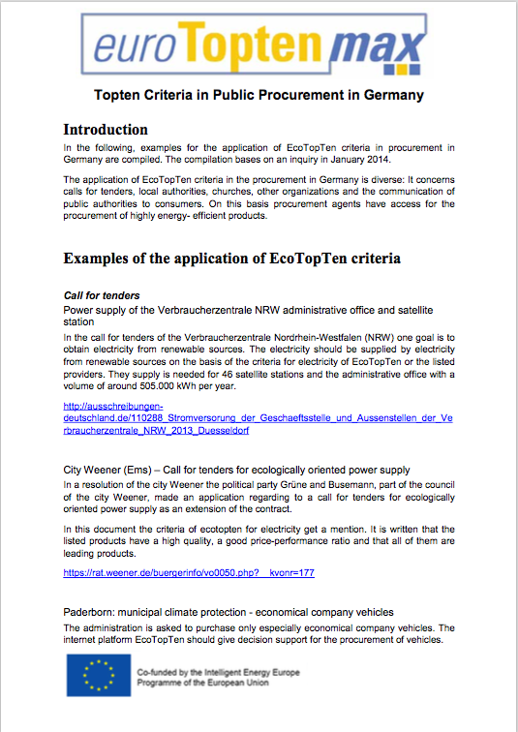

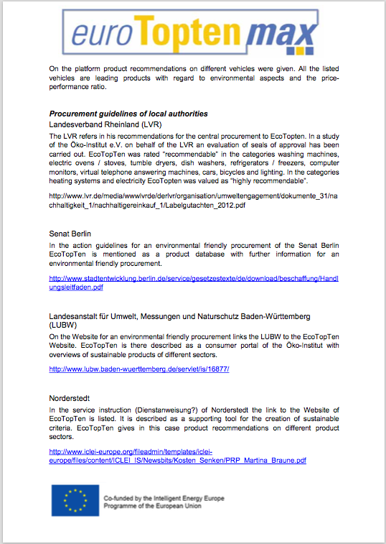

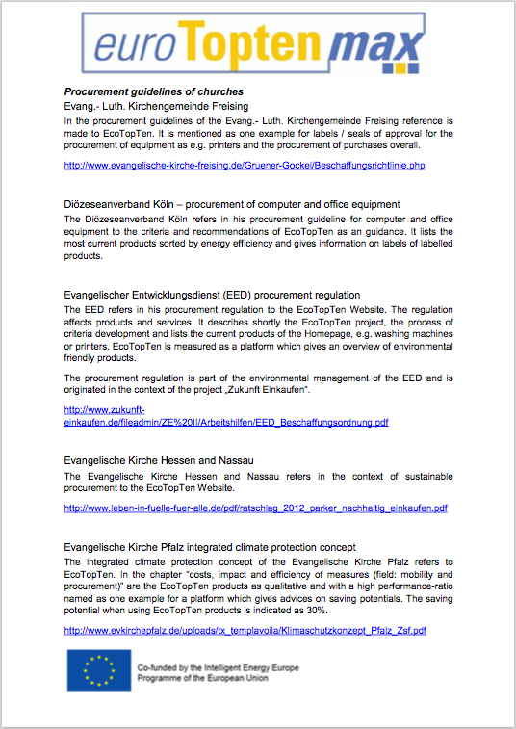

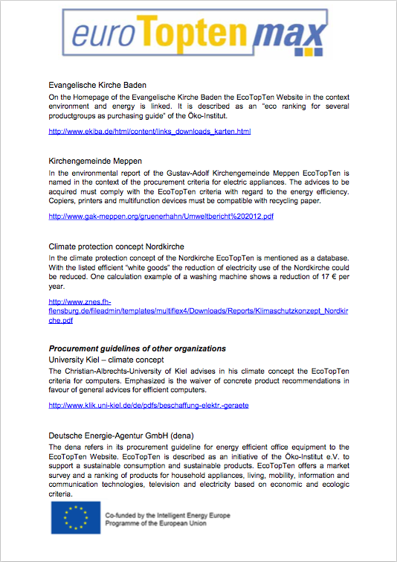

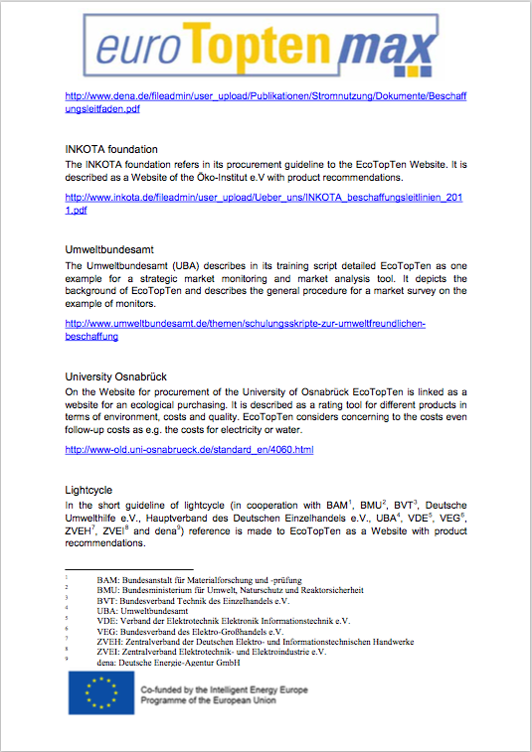

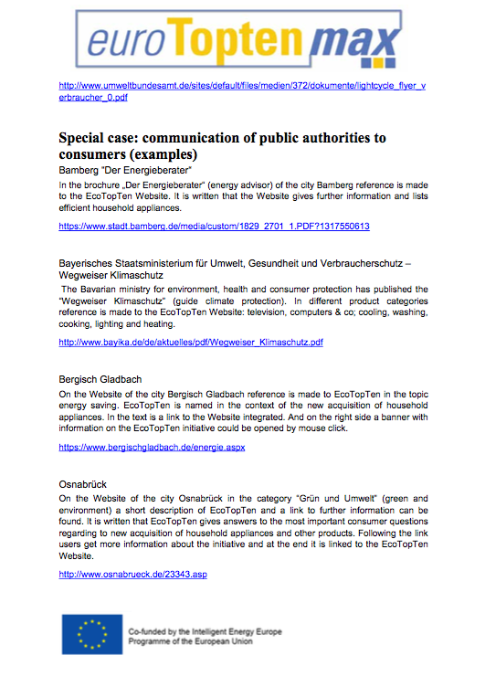

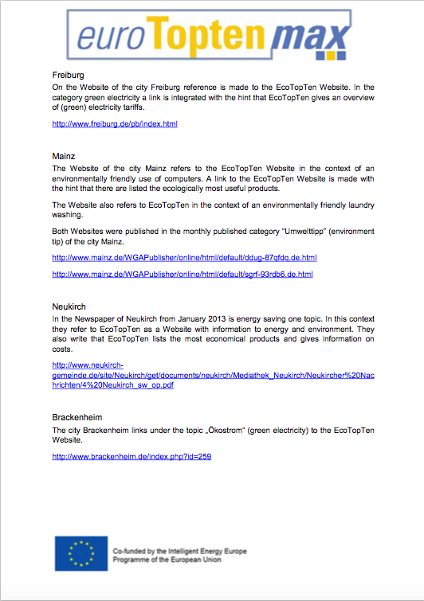

http://www.bmwi.de/EN/Topics/Energy/energy-transition.html
The German Renewable Energy Act (German: Erneuerbare-Energien-Gesetz, EEG) came into force in the year 2000 and was the initial spark of a tremendous boost of renewable energies in Germany.
http://www.ecotopten.de/download/EcoTopTen_Kriterien_Strom_2013.pdf, pages 3-10.
http://www.ecotopten.de/download/EcoTopTen_Strom_2013.pdf
With the "Fund model" the electricity supplier provides the customers with power that originates either from renewables and CHP or from conventional electricity (supply part of the fund model). In order to generate the required additional environmental value, a portion of the electricity price (subsidised amount) must be paid into a fund for the financial support of power plants, which (in the case of RES-E plants) feed their electricity into the grid under the German RES Legislation (EEG).
EcoTopTen power criteria 2013 p. 10

