Guidelines for Frontrunner Public Procurers

Minibars &  Wine Coolers  Updated: August 2016 | 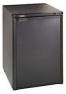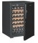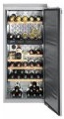

Why follow Topten/ProCold criteria?

- ProCold (www.topten.eu/pro-cold) is an EU-project aiming to improve energy efficiency in plug-in cabinets and speed up the switch to climate-friendly refrigerants. The project provides help for manufacturers, suppliers, food and beverage companies, retailers, gastronomy, hotels, public authorities, media and other stakeholders.
- Topten (www.topten.eu) is a European web portal helping professionals, public procurers and large buyers to find the most energy efficient products available in Europe. The products are selected and updated continuously, according to their high energy and environmental performances, independently from the manufacturers.
- All minibars and wine coolers displayed on www.topten.eu meet the criteria contained in these guidelines. Procurers can therefore use the website to check the availability and assortment of products currently on the market, which meet the Topten selection criteria.
- Topten.eu/pro-cold links to national partners’ Topten websites and is developed under the ProCold-project, supported by the European Union through the Horizon 2020 programme.

How much can you save?

On www.topten.eu there is one category for minibars and another for wine coolers which is divided in one temperature zone and multi temperature zone.

Considering the models listed on Topten and the following assumptions, it is possible to achieve the savings indicated in the next tables.

Assumptions | Life time expectation: 10 years
 | Electricity cost: 0,20 €/kWh

 |  | Volume (litres) | Refrigerant | Energy (kWh/year) | Electricity costs (€ in 10 years) | Savings (€ in 10 years)
Minibars | Topten model | 40 | R600 | 50 | 100 | 81% energy/unit  440 €/unit
 | Inefficient model | 40 | R717 | 270 | 540

 |  | Volume (litres) | Refrigerant | Energy (kWh/year) | Electricity costs (€ in 10 years) | Savings (€ in 10 years)
Wine coolers  1 temperature zone | Topten model | 340 | R600a | 121 | 242 | 71% energy/unit  598€/unit
 | Inefficient model | 343 | R600a | 420 | 840
Wine coolers multi temperature zones | Topten model | 450 | R600a | 128 | 256 | 72% energy/unit  664 €/unit
 | Inefficient model | 418 | R600a | 460 | 920
Comparing models with similar net capacity, the Topten models allow electricity savings, in 10 years, from around 660 €/unit for wine coolers multi-temperature zones, to 600 €/unit for wine coolers 1-temperature zone, and to nearly 450 €/unit for minibars. Best models on www.topten.eu consume more than 70% less energy than inefficient models.
In addition, all Topten models use the natural refrigerants R290 (propane) or R600a (isobutane) with global warming potential (GWP) below 4 (compression-type models), or they do not contain any refrigerant in case of Peltier-type (thermoelectric) models.
It is important to note that hotels can save the most energy by choosing a different approach altogether: An alternative to minibars in each room is an energy efficient vending machine or refrigerator available on the floor.

Procurement criteria

The following criteria can be inserted directly into tendering documents. The Topten selection criteria and the product lists are updated regularly. The newest versions are always available at www.topten.eu/pro-cold.

Subject: Highly Energy-Efficient Minibars and Wine Coolers

Technical Specifications
- Energy class
Minibars and wine coolers must have at least the following energy efficiency class, declared according to the EU Energy Label.
Category | Energy class
Minibars | A+
Wine coolers One temperature zone | A+
Wine coolers Multi temperature zones | A

Verification
Bidders must supply the EU Energy Label and technical data according to EU Regulations No. 1060/2010 and No. 643/2009.

- Refrigerants
Compression-type minibars and wine coolers must use refrigerants with global warming potential below 150 such as R290 (propane) or R600a (isobutane).

Verification
Bidders must supply the information on refrigerant type, charge in kg and global warming potential (GWP).

Background Facts
According to EU Regulation No. 517/2014 domestic refrigerators and freezers that contain refrigerants with global warming potential of 150 or more are banned since 1 January 2015.
According to EU Regulation No. 643/2009 some household refrigerating appliances cannot be placed on the market:
Household minibars: |  | Household wine coolers:
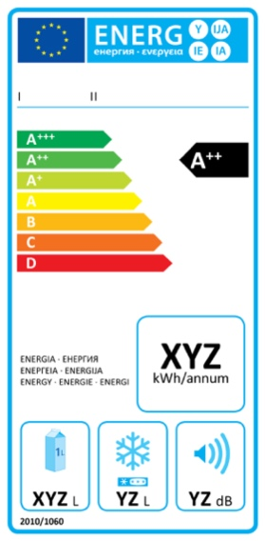 | 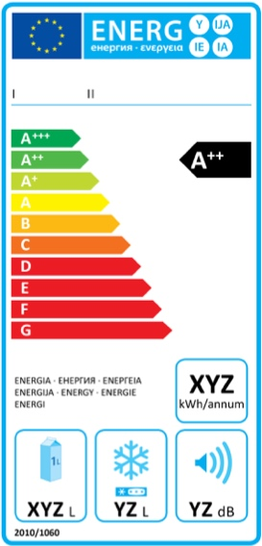 | 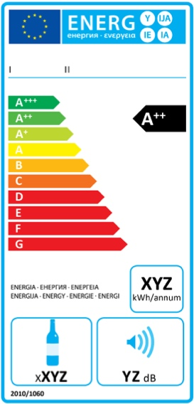
Compression-type refrigerating appliances  Since 1 July 2014 only models with energy class equal or above A+ can be placed on the market | Absorption-type or other-type refrigerating appliances  Since 1 July 2015 only models with energy class equal or above D can be placed on the market | Wine storage appliances  No restrictions

Topten/ProCold appeals to manufacturers to apply these rules to all minibars and wine coolers, independently of whether they are marketed for domestic or professional use.

Energy efficiency class | Energy efficiency index |  | Energy efficiency class | Energy efficiency index
A+++ | EEI <22 |  | C | 75 ≤ EEI < 95
A++ | 22 ≤ EEI < 33 |  | D | 95 ≤ EEI < 110
A+ | 33 ≤ EEI < 42 |  | E | 110 ≤ EEI < 125
A | 42 ≤ EEI < 55 |  | F | 125 ≤ EEI < 150
B | 55 ≤ EEI < 75 |  | G | EEI ≥150

Types, efficiency and noise
Compression-type minibars are by far the most energy efficient ones. On the EU Energy Label compression-type minibars reach the classes A+++ and A++. The best Peltier-type minibars reach A+, but typically they are in lower classes. Absorption-type minibars are inefficient and mostly in class D. Compression-type is also the most efficient technology for wine coolers. The best wine coolers reach classes A++ (one temperature zone) and A+ respectively (multi temperature zone).
Noise is an important criterion especially for minibars. Absorption-type and Peltier-type minibars are silent and have therefore become conventional technology for minibars. Compression-type represents the conventional technology for most other household and commercial appliances. It is the most energy efficient technology, but the compressor makes some noise. The solution for minibars is therefore to install them with a presence sensor or timer that keeps them silent during the guests’ residence in the room. Eutectic plates (= cold storage) guarantee a long cooling time without the need of the compressor starting.

Notes on Implementation
To increase savings and reduce environmental impact, procurers should evaluate life cycle costs when tendering for minibars or wine coolers. Thus, it is advisable to include in the tender a costing exercise - even if simple - for the product life cycle costs.

Example of a breakdown costs table, to be filled in by bidders:
 | Information details | Different unit costs in € (excluding tax) | Total cost in € (excluding tax)
Delivery
Installation
Use | Energy consumption in kWh/year x nº units | Electricity cost: 0,20 €/kWh*
Maintenance
Recycling and disposal
* This figure is just an example. The procurer can use the average electricity price paid during the last 2 or 3 years, and also include subscription fee and taxes.

Advice and support
If you would like further assistance in using the information presented here in your own procurement actions or more information please contact your national Topten team (find the links on www.topten.eu/pro-cold).

