Guidelines for Frontrunner Public Procurers

Computer Monitors  Updated: June 2018 | 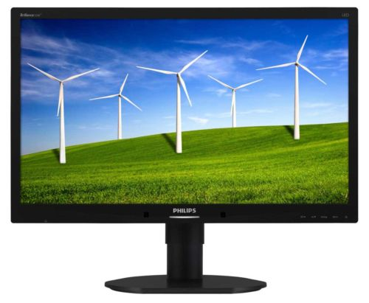

Why follow Topten criteria?

- Topten.eu Pro (www.topten.eu/professional) is a European web portal helping buyers, professionals, public procurers and large buyers to find the most energy efficient products available in Europe. The products are selected and updated continuously, according to their high energy and environmental performances, independently from the manufacturers.
- All computer monitors displayed on www.topten.eu meet the criteria contained in these guidelines. Procurers can therefore use the website to check the availability and assortment of products currently on the market, which meet the Topten selection criteria.
- Topten.eu Pro links to national partners Topten Pro websites and is developed under Topten Act project, supported by the European Union through Horizon 2020 programme.

How much can you save?

Considering the computer monitors from 17 inches upwards listed on www.topten.eu and the following assumptions, it is possible to achieve the savings indicated in the next table.

Assumptions | - Life time expectation: 5 years
 | - Daily use: 8h in on-mode and 16h in sleep-mode
 | - Electricity cost: 0,20 €/kWh

 | Topten model | Inefficient model |  | Topten model | Inefficient model
Screen diagonal (inches) | 19” | 19” |  | 24'' | 24''
Electricity consumption | 26 kWh/year | 44 kWh/year |  | 33 kWh/year | 103 kWh/year
Use cost (electricity in 5 years) | 26 € | 44 € |  | 33 € | 103 €
Savings in 5 years | 40% energy / unit  18€ / unit |  |  | 68% energy / unit  70€ / unit

Differences in electricity consumption between inefficient and Topten models rise as the screen size enlarges, leading to higher energy savings and consequently greater money savings. As the example shows, total savings can reach almost 70% reduction, and they should be multiplied by the number of units included in the tender.

Procurement criteria

The following criteria can be inserted directly into tendering documents. The Topten selection criteria and the product lists are updated regularly. The newest versions are always available at www.topten.eu/pro.

Subject: Highly energy-efficient computer monitors

Technical Specifications
- Sleep-mode power
Maximum Sleep-mode power: 0,5 watts

- On-mode power
The On-mode power must be measured according to the Energy Star Program Requirements for Displays Version 6.0 or 5.1 and must not exceed the following maximum values:

Diagonal (inches) | Maximum power On-mode
15 ≤ d < 17 | 13 watts
17 ≤ d < 20 | 18 watts
20 ≤ d < 22 | 20 watts
d ≥ 22 | 22 watts

Verification
Products bearing the Energy Star Displays Version 6.0 or 5.1 labels with maximum On-mode power corresponding to the above values or lower and with a maximum Sleep-mode power of 0.5 watt will be deemed to comply. Alternatively, bidders may demonstrate compliance with the above requirements by another objective third-party means or by supplying test results in respect of their product demonstrating that the criteria are met. Test results for all modes should be provided using the Energy Star test method.

- Environmental and Ergonomic Features
All products must meet the criteria of TCO Certified Displays 7 or equivalent criteria. Compliance with these criteria is required in respect of the product, not the company itself.
TCO certification (Swedish Label) applies to IT products that meet sustainable environmental and social criteria during their life cycle (manufacturing, use and end of life).

Verification
All products with the TCO Certified Displays 7 label will be accepted. Alternatively bidders may provide documentation to demonstrate that equivalent criteria are met.

Notes on Implementation
It is recommended to apply Environmental and Ergonomic Features as selection criterion to ensure an excellent ergonomic performance as well as to address other environmental criteria. However, if a product does not have the TCO label and instead provides extensive technical documentation this may require additional work on behalf of the procurer.
There are numerous models that comply with these criteria available in the market and in the product lists at www.topten.eu.

Apart from the TCO Certification, there are other certifications that might be taken into account when procuring monitors such as:
- EU Ecolabel recognises products that have a lower environmental impact during their life cycle (raw materials extraction, production, use and disposal).
- Blauer Engel (German Label) which requires Energy Star V. 6.0 and has requirements for reparability, recyclability, material, ergonomics and consumer information. Some of these criteria are aligned with TCO Certified Displays.
These certifications might be used as award/evaluation criteria and if so, X% (at least 10-15%) of the total marks available should be given to products certified by one of both certifications.

To increase savings and reduce environmental impact, procurers should evaluate life cycle costs when tendering for computer monitors. Thus, it is advisable to include in the tender a costing exercise - even if simple - for the product life cycle costs.

Example of a breakdown costs table, to be filled in by bidders:
 | Information details | Different unit costs in € (excluding tax) | Total cost in € (excluding tax)
Delivery
Installation
Use* | - Indicate on mode, sleep and off-mode power, in W  - Specify daily use hours for on, sleep and off modes x 365 days x 5 years x nº units | Electricity cost: 0,20 €/kWh**
Maintenance
Recycling and disposal
* Example of how use costs can be determined. The variables for the costs calculation during the product life time can be stated by the procurer (according to the equipment replacement rate, its daily use in the different modes, the number of days the equipment is in use, etc.).
** This figure is just an example. The procurer can use the average electricity price paid during the last 2 or 3 years, and also include subscription fee and taxes.

Advice and support
If you would like further assistance in using the information presented here in your own procurement actions or more information on Topten Pro please contact your national Topten team (find the links on Topten.eu).

The European Commission’s Green Public Procurement website also contains valuable legal and practical guidance together with procurement criteria for a range of commonly procured products and services.

