**Guidelines for Topten Public Procurers**

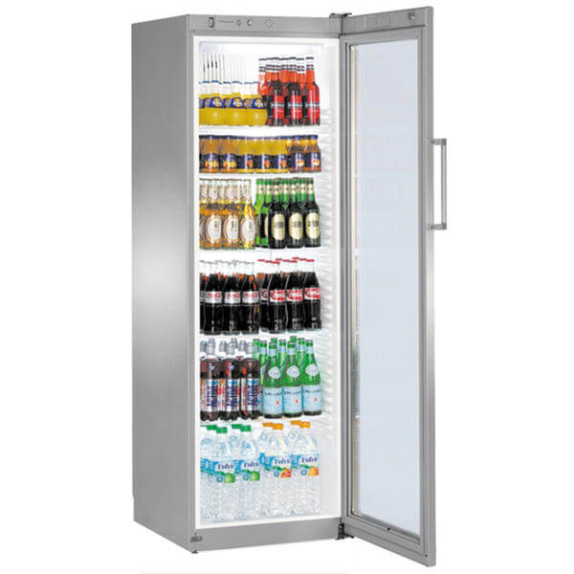

|  |  |
| --- | --- |
| Beverage Coolers  [Steffen Hepp](mailto:steffen.hepp@topten.ch), July 2021 | Beschreibung: http://www.topten.eu/uploads/icons/detail/products/houshold/dishwasher/sn26.jpg |

# Why follow Topten criteria?

* Topten.eu/pro ([www.topten.eu/pro](http://www.topten.eu/pro)) is a European web portal helping buyers, professionals, public procurers and large buyers to find the most energy efficient products available in Europe. The products are selected and updated continuously, according to their high energy and environmental performances, independently from the manufacturers.
* The Topten criteria below can be inserted directly into tendering documents.
* All beverage coolers displayed on [www.topten.eu](http://www.topten.eu) meet the criteria contained in these guidelines. Procurers can therefore use the website to check the availability and assortment of products currently on the market, which meet the [**Topten selection criteria for Beverage Coolers**](https://www.topten.eu/private/selection-criteria/beverage-coolers).
* Topten.eu/pro links to national partners Topten Pro websites and was developed under the Topten Act project, supported by the European Union through Horizon 2020 programme.

# How much can you save?

The scope of beverage coolers listed on [www.topten.eu](http://www.topten.eu) are

* plug-in cabinets (remote cabinets are not considered)
* have forced-air circulation or are capable of pulling down temperature within 4 hours,

Considering the models listed on Topten and the following assumptions, it is possible to achieve the savings indicated in the next table.

|  |  |
| --- | --- |
| Assumptions | Lifetime expectation: 8 years |
| Electricity cost: 0,20 €/kWh |

|  |  |  |  |  |  |
| --- | --- | --- | --- | --- | --- |
|  |  | **Volume (litres)** | **Energy (kWh/year)** | **Electricity costs (€ in 8 years)** | **Savings (€ in 8 years)** |
|  |  |  |  |  |  |
| **Beverage Cooler** | Topten model | 416 | 425 | 680 | **69% energy/unit 1,527 €/unit** |
| Inefficient model | 500 | 1,380 | 2,208 |

Comparing models with similar net capacity, a Topten model allow electricity savings, in 8 years, of around 1,527 €/unit. Best models on [www.topten.eu](http://www.topten.eu) consume almost 70% less energy than inefficient models.

# Procurement criteria

The following criteria can be inserted directly into tendering documents. The Topten selection criteria and the product lists are updated regularly. The newest versions are always available at [**www.topten.eu/pro**](https://www.topten.eu/private/page/pro)**.**

**Subject: Highly energy-efficient Beverage Coolers**

Technical Specifications

1. **Refrigerants**

* Natural refrigerant with global warming potential (GWP) ≤ 3 (e.g. R290/propane, R600a/isobutane, R744/CO2)

***Verification***

Bidders must supply the information on refrigerant(s) used.

1. **Energy class**

* Beverage coolers must have the **Energy class C** or better (maximum EEI of 35), declared according to European Energy Label
* Beverage coolers with R744 refrigerant must have Energy class D or better (maximum EEI of 50)

***Verification***

Bidders must supply the energy label and technical data according to EU Regulations No. 2019/2018 and No. 2019/2024.

Background Information

|  |  |  |  |  |  |  |  |  |  |  |  |  |  |  |  |  |  |  |  |  |
| --- | --- | --- | --- | --- | --- | --- | --- | --- | --- | --- | --- | --- | --- | --- | --- | --- | --- | --- | --- | --- |
|  | |  |  | | --- | --- | | **EU Regulation No 2019/2018** | | | **Energy efficiency class** | **Energy efficiency index** | | A | EEI < 10 | | B | 10 ≤ EEI < 20 | | C | 20 ≤ EEI < 35 | | D | 35 ≤ EEI < 50 | | E | 50 ≤ EEI < 65 | | F | 65 ≤ EEI < 80 | | G | EEI ≥ 80 | | Since 1st March 2021, the EU energy label for refrigerating appliances with a direct sales function (incl. beverage coolers) is mandatory. It shows:   * the energy efficiency class; * the annual electricity consumption in kWh per year; * the gross volume of chilled compartments; * the highest average compartment temperature of all compartments chilled * the warmest ambient temperature   Document: EU regulation No. 2019/2018. |

Beverage coolers with EEI > 100 are not been permitted on the market since March 2021. Products with EEI > 80 will be banned as of September 1st 2023.

Notes on Implementation

To increase savings and reduce environmental impact, procurers should evaluate life cycle costs when tendering for beverage coolers. Thus, it is advisable to include in the tender a costing exercise - even if simple - for the product life cycle costs.

**Example of a breakdown costs table, to be filled in by bidders:**

|  |  |  |  |
| --- | --- | --- | --- |
|  | **Information details** | **Different unit costs in € (excluding tax)** | **Total cost in € (excluding tax)** |
| **Delivery** |  |  |  |
| **Installation** |  |  |  |
| **Use** | Energy consumption in kWh/year x nº units | Electricity cost: 0,20 €/kWh* |  |
| **Maintenance** |  |  |  |
| **Recycling and disposal** |  |  |  |

* Example of how use costs can be determined.

** This figure is just an example. The procurer can use the average electricity price paid during the last 2 or 3 years, and also include subscription fee and taxes.

# Advice and support

If you would like further assistance in using the information presented here in your own procurement actions or more information on [Topten Pro](http://www.topten.eu/pro) contact your national Topten team (find it on Topten.eu).

The European Commission’s [Green Public Procurement](http://ec.europa.eu/environment/gpp/index_en.htm) website contains valuable legal and practical guidance together with procurement criteria for a range of commonly procured products and services.

|  |  |
| --- | --- |
| WWF | The elaboration of these procurement guidelines has been supported by funding from WWF Switzerland. The sole responsibility for the content of the Topten procurement guidelines lies with the authors. |

|  |  |
| --- | --- |
| Ein Bild, das ClipArt enthält.  Automatisch generierte Beschreibung | Topten ACT has received funding from the [European Union's Horizon 2020 research and innovation programme](https://ec.europa.eu/programmes/horizon2020) under grant agreement nº649647. The sole responsibility for the content of the Topten Pro procurement guidelines lies with the authors. It does not necessarily reflect the opinion of the European Union. Neither EASME, nor European Commission and project partners are responsible for any use that may be made of the information contained therein. |