**Guidelines for Topten Public Procurers**

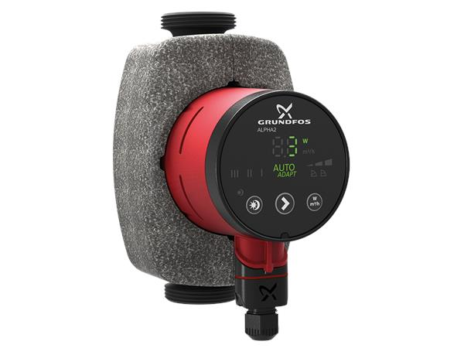

|  |  |
| --- | --- |
| Circulation Pumps  [Steffen Hepp](mailto:steffen.hepp@topten.ch), July 2021 | Beschreibung: http://www.topten.eu/uploads/icons/detail/products/houshold/dishwasher/sn26.jpg |

# Why follow Topten criteria?

* Topten.eu/pro ([www.topten.eu/pro](http://www.topten.eu/pro)) is a European web portal helping buyers, professionals, public procurers and large buyers to find the most energy efficient products available in Europe. The products are selected and updated continuously, according to their high energy and environmental performances, independently from the manufacturers.
* The Topten criteria below can be inserted directly into tendering documents.
* All circulation pumps displayed on [www.topten.eu](http://www.topten.eu) meet the criteria contained in these guidelines. Procurers can therefore use the website to check the availability and assortment of products currently on the market, which meet the [Topten selection criteria for Circulation Pumps](https://www.topten.eu/private/selection-criteria/circulation-pumps).
* Topten.eu/pro links to national partners Topten Pro websites and was developed under the Topten Act project, supported by the European Union through Horizon 2020 programme.

# How much can you save?

The category circulation pumps, listed on [www.topten.eu](http://www.topten.eu), includes circulation pumps for heating systems of Europe - standalone pumps or integrated in a product. Considering the following assumptions, it is possible to achieve the savings indicated in the next table.

|  |  |
| --- | --- |
| Assumptions | * Lifetime expectation: 15 years |
| * Yearly use: 5,040 hours (seven months heating period) |
| * Electricity cost: 0.20 €/kWh |

|  |  |  |
| --- | --- | --- |
|  | **Topten model** | **Inefficient model** |
| Type | modern pump | old pump |
| Average Power (in W) | 15 | 75 |
| Electricity consumption | 76 kWh/year | 378 kWh/year |
| **Use cost** (electricity in 15 yrs) | 227 € | 1,134 € |
| **Savings in 15 years** | **80% energy / unit ⇨ 907 € / unit** | |

A Topten models has electricity savings of 80% compared to an inefficient and old pump. Over the pump’s life time of 15 years, savings of more than 900 € / unit can be achieved.

# Procurement criteria

The following criteria can be inserted directly into tendering documents. The Topten selection criteria and the product lists are updated regularly. The newest versions are always available at [**www.topten.eu/pro**](https://www.topten.eu/private/page/pro)**.**

**Subject: Highly energy-efficient circulation pumps**

Technical Specifications

1. Circulation Pumps Energy must have an Efficiency Index equal to or lower than 0.18, declared according to EU Eco-design Regulation No. 641/2009.

***Verification***

Bidders must supply the technical data according to EU Regulations No. 641/2009.

Further Information

**Energy Efficiency Index**

The EEI is an indicator of a circulator's efficiency. The EEI is defined in the Eco-design Regulation for circulators No. 641/2009, and it must be indicated on the name plate, the packaging and the technical documentation. The lower the EEI, the higher a product's energy efficiency is.

The EEI replaces the previous energy label with classes A to G since Jan 2013. Since August 2015, an EEI of ≤ 0.23 is mandatory.

To increase savings and reduce environmental impact, procurers should evaluate life cycle costs when tendering for circulation pumps. Thus, it is advisable to include in the tender a costing exercise - even if simple - for the product life cycle costs.

Example of a breakdown costs table, to be filled in by bidders

|  |  |  |  |
| --- | --- | --- | --- |
|  | **Information details** | **Different unit costs in € (excluding tax)** | **Total cost in € (excluding tax)** |
| **Delivery** |  |  |  |
| **Installation** |  |  |  |
| **Use\*** | Energy consumption in kWh/year x product life time (15 yrs) x nº units | Electricity cost**: 0,20 €/kWh |  |
| **Maintenance** |  |  |  |
| **Recycling and disposal** |  |  |  |

* Example of how use costs can be determined.

** This figure is just an example. The procurer can use the average electricity price paid during the last 2 or 3 years, and also include subscription fee and taxes.

# Advice and support

If you would like further assistance in using the information presented here in your own procurement actions or more information on [Topten Pro](http://www.topten.eu/pro) contact your national Topten team (find it on Topten.eu).

The European Commission’s [Green Public Procurement](http://ec.europa.eu/environment/gpp/index_en.htm) website contains valuable legal and practical guidance together with procurement criteria for a range of commonly procured products and services.

|  |  |
| --- | --- |
| WWF | The elaboration of these procurement guidelines has been supported by WWF Switzerland. The sole responsibility for the content of the Topten procurement guidelines lies with the authors. |

|  |  |
| --- | --- |
| Ein Bild, das ClipArt enthält.  Automatisch generierte Beschreibung | This HACKS project (Heating and Cooling Knowhow and Solutions) has received funding from the [European Union's Horizon 2020 research and innovation programme](https://ec.europa.eu/programmes/horizon2020) under grant agreement nº845231. The sole responsibility for the content of the Topten Pro procurement guidelines lies with the authors. It does not necessarily reflect the opinion of the European Union. Neither EASME, nor European Commission and project partners are responsible for any use that may be made of the information contained therein. |