**Guidelines for Topten Public Procurers**

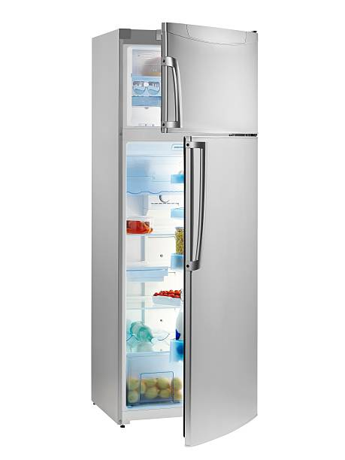

|  |  |
| --- | --- |
| Household Refrigerators  [Steffen Hepp](mailto:steffen.hepp@topten.ch), June 2021 | Beschreibung: http://www.topten.eu/uploads/icons/detail/products/houshold/dishwasher/sn26.jpg |

# Why follow Topten criteria?

* Topten.eu/pro ([www.topten.eu/pro](http://www.topten.eu/pro)) is a European web portal helping buyers, professionals, public procurers and large buyers to find the most energy efficient products available in Europe. The products are selected and updated continuously, according to their high energy and environmental performances, independently from the manufacturers.
* The Topten criteria below can be inserted directly into tendering documents.
* All household refrigerators displayed on [www.topten.eu](http://www.topten.eu) meet the criteria contained in these guidelines. Procurers can therefore use the website to check the availability and assortment of products currently on the market, which meet the [Topten selection criteria for Household Refrigerators](https://www.topten.eu/private/selection-criteria/household-refrigerators).
* Topten.eu/pro links to national partners Topten Pro websites and was developed under the Topten Act project, supported by the European Union through Horizon 2020 programme.

# How much can you save?

The category household refrigerators, listed on [www.topten.eu](http://www.topten.eu), includes built-in and freestanding refrigerators, each with and without an additional freezer compartment (also ‘refrigerator-freezer combination’).

Considering the following assumptions, it is possible to achieve the savings indicated in the next table.

|  |  |
| --- | --- |
| Assumptions | * Lifetime expectation: 15 years |
| * Daily use: 24h in use-mode |
| * Electricity cost: 0.20 €/kWh |

|  |  |  |  |  |  |
| --- | --- | --- | --- | --- | --- |
|  | **Topten model** | **Inefficient model** |  | **Topten model** | **Inefficient model** |
| Type | Refrigerator | Refrigerator |  | Refrigerator-freezer | Refrigerator-freezer |
| Net volume (liter) | 161 | 161 |  | 256 | 256 |
| Energy class | D | F |  | D | F |
| Electricity consumption | 127 kWh/year | 191 kWh/year |  | 182 kWh/year | 273 kWh/year |
| **Use cost (electricity in 15 yrs)** | 381 € | 573 € |  | 546 € | 819 € |
| **Savings in 15 years** | **34% energy / unit ⇨ 192 € / unit** | |  | **33% energy / unit ⇨ 273 € / unit** | |

The savings potential for a Topten model compared to an inefficient model is significant. In the example the electricity saving for a Topten refrigerator is 34%, for a refrigerator with a freezer compartment savings are 33%. Over the product life time of 15 years these efficiencies accumulate to 192 € per unit and 273 € per unit respectively.

Differences in electricity consumption between inefficient and Topten models rise as the net capacity grows, leading to higher energy savings and consequently greater money savings.

# Procurement criteria

The following criteria can be inserted directly into tendering documents. The Topten selection criteria and the product lists are updated regularly. The newest versions are always available at [**www.topten.eu/pro**](https://www.topten.eu/private/page/pro)**.**

**Subject: Highly energy-efficient Household Refrigerators**

Technical Specifications

**Energy class**

Household refrigerators must have an energy class between A and D, declared in agreement with the European Energy Label.

**Refrigerants**Consumer refrigerators must not use any refrigerants, i.e., be free of CFC and HFC.

***Verification***

Bidders must supply the energy label and technical data according to EU Regulations No. 2019/2019 and No. 2019/2016.

Table 1: Overview of energy classes allowed on the European market

|  |  |  |
| --- | --- | --- |
|  | **Commission Delegated Regulation nº 2019/2016** | |
| **Energy efficiency class** | **Energy efficiency index** |
| A | EEI ≤ 41 |
| B | 41 < EEI ≤ 51 |
| C | 51 < EEI ≤ 64 |
| D | 64 < EEI ≤ 80 |
| E | 80 < EEI ≤ 100 |
| F | 100 < EEI ≤ 125 |
| G | EEI > 125 |
| Note: The lower the value, the better the efficiency of the device | |

Since 1 March 2021 the revised EU energy label for household refrigerating appliances is mandatory. It shows:

* the energy efficiency class;
* the annual electricity consumption in kWh per year;
* the net volume of refrigerator compartments;
* noise emission classes (A to D) that help compare noise levels

Further Remarks

To increase savings and reduce environmental impact, procurers should evaluate life cycle costs when tendering for household refrigerators. Thus, it is advisable to include in the tender a costing exercise - even if simple - for the product life cycle costs.

Table 2: Example of a breakdown costs table, to be filled in by bidders

|  |  |  |  |
| --- | --- | --- | --- |
|  | **Information details** | **Different unit costs in € (excluding tax)** | **Total cost in € (excluding tax)** |
| **Delivery** |  |  |  |
| **Installation** |  |  |  |
| **Use\*** | Energy consumption in kWh/year x product life time (15 yrs) x nº units | Electricity cost**: 0,20 €/kWh |  |
| **Maintenance** |  |  |  |
| **Recycling and disposal** |  |  |  |

* Example of how use costs can be determined.

** This figure is just an example. The procurer can use the average electricity price paid during the last 2 or 3 years, and also include subscription fee and taxes.

# Advice and support

If you would like further assistance in using the information presented here in your own procurement actions or more information on [Topten Pro](http://www.topten.eu/pro) contact your national Topten team (find it on Topten.eu).

The European Commission’s [Green Public Procurement](http://ec.europa.eu/environment/gpp/index_en.htm) website contains valuable legal and practical guidance together with procurement criteria for a range of commonly procured products and services.

|  |  |
| --- | --- |
| WWF | The elaboration of these procurement guidelines has been supported by funding from WWF Switzerland. The sole responsibility for the content of the Topten procurement guidelines lies with the authors. |

|  |  |
| --- | --- |
| Ein Bild, das ClipArt enthält.  Automatisch generierte Beschreibung | Topten ACT has received funding from the [European Union's Horizon 2020 research and innovation programme](https://ec.europa.eu/programmes/horizon2020) under grant agreement nº649647. The sole responsibility for the content of the Topten Pro procurement guidelines lies with the authors. It does not necessarily reflect the opinion of the European Union. Neither EASME, nor European Commission and project partners are responsible for any use that may be made of the information contained therein. |