**Guidelines for Topten Public Procurers**

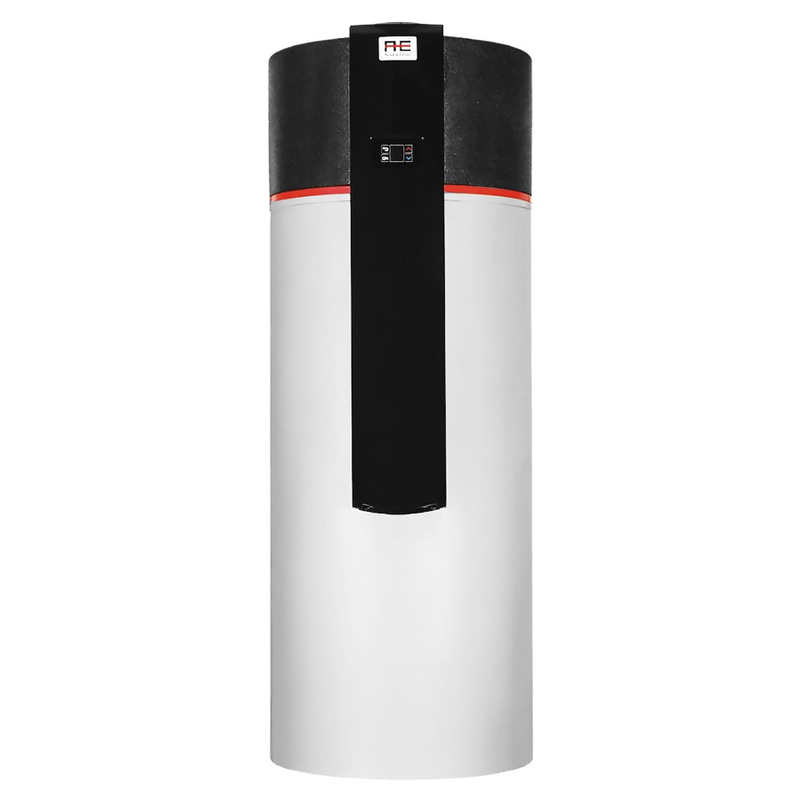

|  |  |
| --- | --- |
| Electric Water Heaters  [Steffen Hepp](mailto:steffen.hepp@topten.ch), June 2021 | Beschreibung: http://www.topten.eu/uploads/icons/detail/products/houshold/dishwasher/sn26.jpg |

# Why follow Topten criteria?

* Topten.eu/pro ([www.topten.eu/pro](http://www.topten.eu/pro)) is a European web portal helping buyers, professionals, public procurers and large buyers to find the most energy efficient products available in Europe. The products are selected and updated continuously, according to their high energy and environmental performances, independently from the manufacturers.
* The Topten criteria below can be inserted directly into tendering documents.
* All electrical water heaters displayed on [www.topten.eu](http://www.topten.eu) meet the criteria contained in these guidelines. Procurers can therefore use the website to check the availability and assortment of products currently on the market, which meet the [Topten selection criteria for Electric Water Heaters](https://www.topten.eu/private/selection-criteria/electric-water-heaters).
* Topten.eu/pro links to national partners Topten Pro websites and was developed under the Topten Act project, supported by the European Union through Horizon 2020 programme.

# How much can you save?

There are many different systems to supply domestic hot water. The energy used varies from oil or gas boilers, to electrical resistance heaters or (electrical) air source heat pumps, to renewable sources like solar collectors, wood or industrial waste heat.

The electric water heaters, listed on www.topten.eu, are all heat pump water heaters. These systems prove much more energy efficient than electrical resistance heaters, which is shown in the example below.

Considering the following assumptions, it is possible to achieve the savings indicated in the next table.

|  |  |
| --- | --- |
| Assumptions | * Lifetime expectation: 15 years |
| * Annual energy consumption in kWh as per energy label |
| * Electricity cost: 0.20 €/kWh |

|  |  |  |
| --- | --- | --- |
|  | **Topten model** | **Inefficient model** |
| Type | Heat pump water heater | Electrical resistance heater |
| Net volume (liter) | 300 | 300 |
| Electricity consumption | 1,058 kWh/year | 4,490 kWh/year |
| Use cost (electricity in 15 yrs) | 3,174 € | 13,470 € |
| Purchase price for heater | 5,500 € | 2,000 € |
| **Total cost** | 8.674 € | 15,470 € |
| **Savings in 15 years** | **76% energy / unit ⇨ Saved 6,796 € / unit** | |

The savings potential for a Topten model compared to an inefficient model is significant.

The purchase price of a heat pump water heater is more expensive than a conventional electrical resistance heater.

Yet, the savings in energy costs of (76% less) more than compensate the higher initial investment. The **total cost after 15 years (energy + purchase price) is 44% lower** **with a heat pump system,** **resulting in ~6,800 € savings.**

Differences in electricity consumption between inefficient and Topten models rise as the net capacity (liter water tank) grows, leading to higher energy savings and consequently greater money savings.

# Procurement criteria

The following criteria can be inserted directly into tendering documents. The Topten selection criteria and the product lists are updated regularly. The newest versions are always available at [**www.topten.eu/pro**](https://www.topten.eu/private/page/pro)**.**

**Subject: Highly energy-efficient electrical water heaters**

Technical Specifications

Electrical water heater must be a ‘heat pump water heater’ of type that meets the following criteria, declared according to the EU energy label:

* Energy class A+

***Verification***

Bidders must supply the energy label and technical data according to EU Regulations No. 812/2013 and No. 814/2013.

Further Information

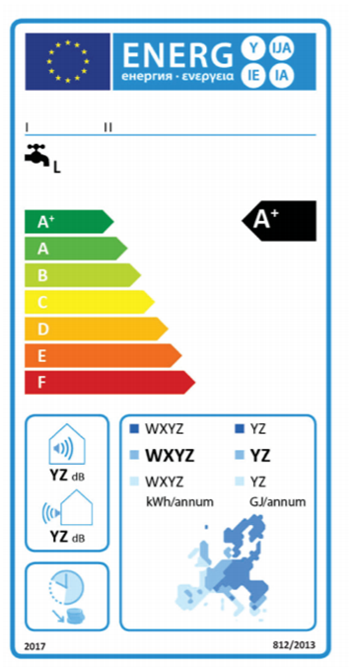

The EU Energy Label for heat pump water heaters is in place since 2013 and shows:

* the energy efficiency class;
* the annual electricity consumption in kWh per year;
* the ability to work only to during off-peak hours

To increase savings and reduce environmental impact, procurers should evaluate life cycle costs when tendering for electrical water heaters. Thus, it is advisable to include in the tender a costing exercise - even if simple - for the product life cycle costs.

Table 1: Example of a breakdown costs table, to be filled in by bidders

|  |  |  |  |
| --- | --- | --- | --- |
|  | **Information details** | **Different unit costs in € (excluding tax)** | **Total cost in € (excluding tax)** |
| **Delivery** |  |  |  |
| **Installation** |  |  |  |
| **Use\*** | Energy consumption in kWh/year x product life time (15 yrs) x nº units | Electricity cost**: 0,20 €/kWh |  |
| **Maintenance** |  |  |  |
| **Recycling and disposal** |  |  |  |

* Example of how use costs can be determined.

** This figure is just an example. The procurer can use the average electricity price paid during the last 2 or 3 years, and also include subscription fee and taxes.

# Advice and support

If you would like further assistance in using the information presented here in your own procurement actions or more information on [Topten Pro](http://www.topten.eu/pro) contact your national Topten team (find it on Topten.eu).

The European Commission’s [Green Public Procurement](http://ec.europa.eu/environment/gpp/index_en.htm) website contains valuable legal and practical guidance together with procurement criteria for a range of commonly procured products and services.

|  |  |
| --- | --- |
| WWF | The elaboration of these procurement guidelines has been supported by WWF Switzerland. The sole responsibility for the content of the Topten procurement guidelines lies with the authors. |

|  |  |
| --- | --- |
| Ein Bild, das ClipArt enthält.  Automatisch generierte Beschreibung | This HACKS project (Heating and Cooling Knowhow and Solutions) has received funding from the [European Union's Horizon 2020 research and innovation programme](https://ec.europa.eu/programmes/horizon2020) under grant agreement nº845231. The sole responsibility for the content of the Topten Pro procurement guidelines lies with the authors. It does not necessarily reflect the opinion of the European Union. Neither EASME, nor European Commission and project partners are responsible for any use that may be made of the information contained therein. |