**Guidelines for Topten Public Procurers**

|  |  |
| --- | --- |
| TV Sets  [Steffen Hepp](mailto:steffen.hepp@topten.ch), June 2021 | Beschreibung: http://www.topten.eu/uploads/icons/detail/products/houshold/dishwasher/sn26.jpg |

# Why follow Topten criteria?

* Topten.eu/pro ([www.topten.eu/pro](http://www.topten.eu/pro)) is a European web portal helping buyers, professionals, public procurers and large buyers to find the most energy efficient products available in Europe. The products are selected and updated continuously, according to their high energy and environmental performances, independently from the manufacturers.
* The Topten criteria below can be inserted directly into tendering documents.
* All TV sets displayed on [www.topten.eu](http://www.topten.eu) meet the criteria contained in these guidelines. Procurers can therefore use the website to check the availability and assortment of products currently on the market, which meet the [Topten selection criteria for Television sets](https://www.topten.eu/private/selection-criteria/television-sets).
* Topten.eu/pro links to national partners Topten Pro websites and was developed under the Topten Act project, supported by the European Union through Horizon 2020 programme.

# How much can you save?

Considering television sets listed on [www.topten.eu](http://www.topten.eu) and the following assumptions, it is possible to achieve the savings indicated in the next table.

|  |  |
| --- | --- |
| Assumptions | * Lifetime expectation: 10 years |
| * Daily use: 4h in on-mode |
| * Electricity cost: 0.20 €/kWh |

|  |  |  |  |  |  |
| --- | --- | --- | --- | --- | --- |
|  | **Topten model** | **Inefficient model** |  | **Topten model** | **Inefficient model** |
| Screen diagonal | 109cm / 43" | 109cm / 43" |  | 165cm / 65" | 165cm / 65" |
| Energy class | E | F |  | E | G |
| Resolution | HD | HD |  | 4K | 4K |
| Electricity consumption | 42 kWh/1000h | 51 kWh/1000h |  | 85 kWh/1000h | 126 kWh/1000h |
| **Use cost (electricity in 10 years)** | 121 € | 147 € |  | 245 € | 363 € |
| **Savings in 10 years** | **18% energy / unit ⇨ 26 € / unit** | |  | **33% energy / unit ⇨ 118 € / unit** | |

Differences in electricity consumption between inefficient and Topten models rise as the screen size enlarges, leading to higher energy savings and consequently greater money savings. As the example shows, total savings can reach 33% reduction, and they should be multiplied by the number of units included in the tender.

The calculation assumes a home usage of four hours per day. Due to longer daily usage, energy consumption and potential savings by TVs are higher in a professional environment than for home TVs.

# Procurement criteria

The following criteria can be inserted directly into tendering documents. The Topten selection criteria and the product lists are updated regularly. The newest versions are always available at [**www.topten.eu/pro**](https://www.topten.eu/professional)**.**

**Subject: Highly energy-efficient Television sets**

Technical Specifications

**Energy class**

Televisions sets must have energy efficiency class F or better (efficiency index < 0.90), declared in agreement with the European Energy Label.

This applies to all TV models independent of their resolution.

***Verification***

Bidders must supply the energy label and technical data according to EU Regulations No. 2019/2021 and No. 2019/2013.

Notes on Implementation

**Screen definitions**

Currently, 4K or 4K UHD (Ultra High Definition) constitute for the majority of TVs offered in the market. While Full HD offered a resolution of 1920 x 1280 pixels, 4K has a resultion of 3840 horizontal pixels x 2160 vertical pixels.

So far, 8K or 8K UHD (7680 x 4320 pixels) TVs have started to emerge, yet have not gained significant popularity given its lack of availablity and high prices.

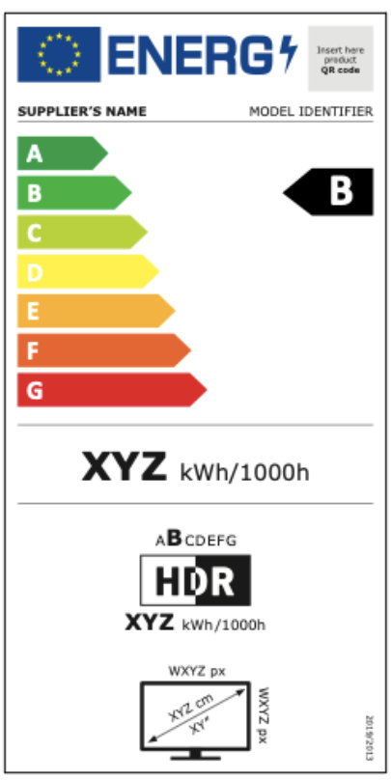

Table 1: Overview of energy classes allowed on the European market

|  |  |
| --- | --- |
| **Commission Delegated Regulation nº 2019/2013** | |
| **Energy efficiency class** | **Energy efficiency index** |
| A | EEI < 0,30 |
| B | 0,30 ≤ EEI < 0,40 |
| C | 0,40 ≤ EEI < 0,50 |
| D | 0,50 ≤ EEI < 0,60 |
| E | 0,60 ≤ EEI < 0,75 |
| F | 0,75 ≤ EEI < 0,90 |
| G | 0,90 ≤ EEI |

**Energy Efficiency Index during On-Mode**

EU Regulation No 2019/2021 states the maximum EEI limits that apply when the TV set is turned on. The EEImax is greater with higher screen resolution.

These limits will become more restrictive as of 2023. It is recommendable to invest into energy efficient devices that already now meet these standards.

Table 2: EEI limits for on-mode

|  |  |  |  |
| --- | --- | --- | --- |
|  | EEImax for HD | EEImax for UHD-4K | EEImax for displays above  UHD-4K resolution |
| 1. March 2021 | 0.90 | 1.10 | n.a. |
| 1. March 2023 | 0.75 | 0.90 | 0.90 |
|  |  |  |  |
| *HD = 2,138,400 pxl* | *UHD-4K = 8,294,400 pxl* |  |  |

To increase savings and reduce environmental impact, procurers should evaluate life cycle costs when tendering for TV sets. Thus, it is advisable to include in the tender a costing exercise - even if simple - for the product life cycle costs.

Table 3: Example of a breakdown costs table, to be filled in by bidders

|  |  |  |  |
| --- | --- | --- | --- |
|  | **Information details** | **Different unit costs in € (excluding tax)** | **Total cost in € (excluding tax)** |
| **Delivery** |  |  |  |
| **Installation** |  |  |  |
| **Use\*** | On mode power (W) x nº daily hours in use x nº annual working days x 10 years x nº units | Electricity cost**: 0,20 €/kWh |  |
| **Maintenance** |  |  |  |
| **Recycling and disposal** |  |  |  |

* Example of how use costs can be determined. The variables for the costs calculation during the product life time can be stated by the procurer (according to the equipment replacement rate, its daily and annual use, etc.).

** This figure is just an example. The procurer can use the average electricity price paid during the last 2 or 3 years, and also include subscription fee and taxes.

# Advice and support

If you would like further assistance in using the information presented here in your own procurement actions or more information on [Topten Pro](http://www.topten.eu/pro) contact your national Topten team (find it on Topten.eu).

The European Commission’s [Green Public Procurement](http://ec.europa.eu/environment/gpp/index_en.htm) website contains valuable legal and practical guidance together with procurement criteria for a range of commonly procured products and services.

|  |  |
| --- | --- |
| WWF | The elaboration of these procurement guidelines has been supported by funding from WWF Switzerland. The sole responsibility for the content of the Topten procurement guidelines lies with the authors. |

|  |  |
| --- | --- |
| Ein Bild, das ClipArt enthält.  Automatisch generierte Beschreibung | Topten ACT has received funding from the [European Union's Horizon 2020 research and innovation programme](https://ec.europa.eu/programmes/horizon2020) under grant agreement nº649647. The sole responsibility for the content of the Topten Pro procurement guidelines lies with the authors. It does not necessarily reflect the opinion of the European Union. Neither EASME, nor European Commission and project partners are responsible for any use that may be made of the information contained therein. |