**Guidelines for Topten Public Procurers**

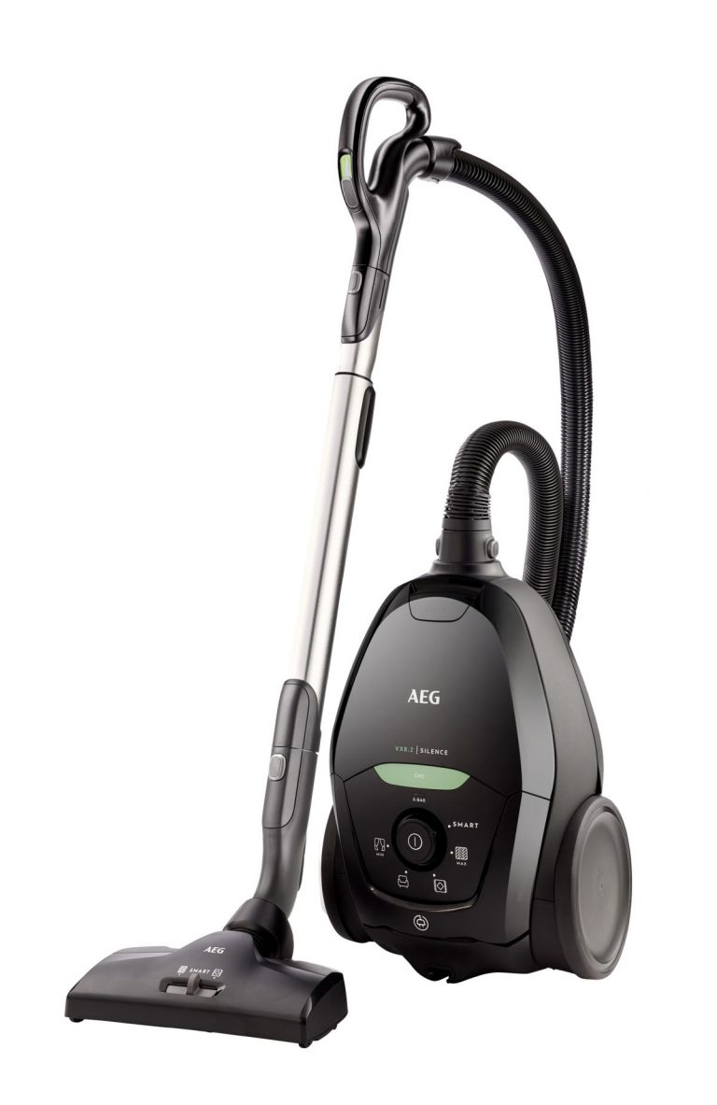

|  |  |
| --- | --- |
| Vacuum Cleaners  [Steffen Hepp](mailto:steffen.hepp@topten.ch), June 2021 | Beschreibung: http://www.topten.eu/uploads/icons/detail/products/houshold/dishwasher/sn26.jpg |

# Why follow Topten criteria?

* Topten.eu/pro ([www.topten.eu/pro](http://www.topten.eu/pro)) is a European web portal helping buyers, professionals, public procurers and large buyers to find the most energy efficient products available in Europe. The products are selected and updated continuously, according to their high energy and environmental performances, independently from the manufacturers.
* The Topten criteria below can be inserted directly into tendering documents.
* All vacuum cleaners displayed on [www.topten.eu](http://www.topten.eu) meet the criteria contained in these guidelines. Procurers can therefore use the website to check the availability and assortment of products currently on the market, which meet the [Topten selection criteria for Vacuum Cleaners](https://www.topten.eu/private/selection-criteria/vacuum-cleaners).
* Topten.eu/pro links to national partners Topten Pro websites and was developed under the Topten Act project, supported by the European Union through Horizon 2020 programme.

# How much can you save?

The category vacuum cleaners, listed on [www.topten.eu](http://www.topten.eu), includes upright and cylinder cleaners, with or without dustbag, and handhelds.

Considering the following assumptions, it is possible to achieve the savings indicated in the next table.

|  |  |
| --- | --- |
| Assumptions | * Lifetime expectation: 10 years |
| * 1 hour use per week |
| * Electricity cost: 0.20 €/kWh |

|  |  |  |  |  |  |
| --- | --- | --- | --- | --- | --- |
|  | **Topten model** | **Inefficient model** |  | **Topten model** | **Inefficient model** |
| Type | with bag | with bag |  | without bag | without bag |
| Power (W) | 400 | 890 |  | 450 | 890 |
| Electricity consumption | 21 kWh/year | 46 kWh/year |  | 23 kWh/year | 46 kWh/year |
| **Use cost (electricity in 10 years)** | 42 € | 93 € |  | 47 € | 93 € |
| **Savings in 10 years** | **55% energy / unit ⇨ 51 € / unit** | |  | **49% energy / unit ⇨ 46 € / unit** | |

The savings potential for a Topten model compared to an inefficient model are significant. A Topten vacuum cleaner with bag can save 55% of energy, one without bag 49%. Over the product life time of 10 years the savings add up to 51 € per unit and 46 € per unit respectively.

# Procurement criteria

The following criteria can be inserted directly into tendering documents. The Topten selection criteria and the product lists are updated regularly. The newest versions are always available at [**www.topten.eu/pro**](https://www.topten.eu/professional)**.**

**Subject: Highly energy-efficient vacuum cleaners**

Technical Specifications

1. **Power**

Maximum rated Power: 650 Watt

***Verification***

Bidders must supply the technical data sheet with information on maximum power input.

Further Remarks

To increase savings and reduce environmental impact, procurers should evaluate life cycle costs when tendering for vacuum cleaners. Thus, it is advisable to include in the tender a costing exercise - even if simple - for the product life cycle costs.

Table 1: Example of a breakdown costs table, to be filled in by bidders

|  |  |  |  |
| --- | --- | --- | --- |
|  | **Information details** | **Different unit costs in € (excluding tax)** | **Total cost in € (excluding tax)** |
| **Delivery** |  |  |  |
| **Installation** |  |  |  |
| **Use\*** | Power input (kW), x hours of use per year x 10 years, x nº units | Electricity cost**: 0,20 €/kWh |  |
| **Maintenance** |  |  |  |
| **Recycling and disposal** |  |  |  |

* Example of how use costs can be determined. The variables for the costs calculation during the product life time can be stated by the procurer (according to the equipment replacement rate, its daily and annual use, etc.).

** This figure is just an example. The procurer can use the average electricity price paid during the last 2 or 3 years, and also include subscription fee and taxes.

# Advice and support

If you would like further assistance in using the information presented here in your own procurement actions or more information on [Topten Pro](http://www.topten.eu/pro) contact your national Topten team (find it on Topten.eu).

The European Commission’s [Green Public Procurement](http://ec.europa.eu/environment/gpp/index_en.htm) website contains valuable legal and practical guidance together with procurement criteria for a range of commonly procured products and services.

|  |  |
| --- | --- |
| WWF | The elaboration of these procurement guidelines has been supported by funding from WWF Switzerland. The sole responsibility for the content of the Topten procurement guidelines lies with the authors. |

|  |  |
| --- | --- |
| Ein Bild, das ClipArt enthält.  Automatisch generierte Beschreibung | Topten ACT has received funding from the [European Union's Horizon 2020 research and innovation programme](https://ec.europa.eu/programmes/horizon2020) under grant agreement nº649647. The sole responsibility for the content of the Topten Pro procurement guidelines lies with the authors. It does not necessarily reflect the opinion of the European Union. Neither EASME, nor European Commission and project partners are responsible for any use that may be made of the information contained therein. |