Guidelines for Frontrunner Public Procurers

Television sets  Updated: June 2018 | 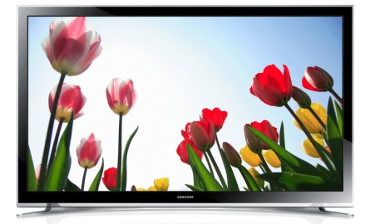

Why follow Topten criteria?

- Topten.eu Pro (www.topten.eu/professional) is a European web portal helping buyers, professionals, public procurers and large buyers to find the most energy efficient products available in Europe. The products are selected and updated continuously, according to their high energy and environmental performances, independently from the manufacturers.
- All television sets displayed on www.topten.eu meet the criteria contained in these guidelines. Procurers can therefore use the website to check the availability and assortment of products currently on the market, which meet the Topten selection criteria.
- Topten.eu Pro links to national partners Topten Pro websites and is developed under Topten Act project, supported by the European Union through Horizon 2020 programme.

How much can you save?

Considering television sets listed on www.topten.eu and the following assumptions, it is possible to achieve the savings indicated in the next table.

Assumptions | - Life time expectation: 10 years
 | - Daily use: 8h in on-mode
 | - Electricity cost: 0.20 €/kWh

 | Topten model | Inefficient model |  | Topten model | Inefficient model
Screen diagonal | 108cm / 42" | 107cm / 42" |  | 139cm / 55" | 139cm / 55"
Energy class | A++ | B |  | A+ | B
Resolution | HD | HD |  | 4K | 4K
Electricity consumption | 88 kWh/year | 275 kWh/year |  | 184 kWh/year | 456 kWh/year
Use cost (electricity in 10 years) | 177 € | 554 € |  | 372 € | 920 €
Savings in 10 years | 66% energy / unit  377€ / unit |  |  | 60% energy / unit  548€ / unit
Differences in electricity consumption between inefficient and Topten models rise as the screen size enlarges, leading to higher energy savings and consequently greater money savings. As the example

shows, total savings can reach 66% reduction, and they should be multiplied by the number of units included in the tender.
Due to longer daily usage, energy consumption and potential savings by TVs are higher in a professional environment than for home TVs. While the annual energy consumption declared on the Energy Label and on Topten.eu is calculated based on an assumed usage of 4 hours per day, for professional use we assume 8 hours per day.

Procurement criteria

The following criteria can be inserted directly into tendering documents. The Topten selection criteria and the product lists are updated regularly. The newest versions are always available at www.topten.eu/pro.

Subject: Highly energy-efficient television sets

Technical Specifications
- Energy class
According to their visible screen diagonal and resolution, television sets must have at least the following energy efficiency class, declared in agreement with the European Energy Label.
TV models with HD resolution or lower
Screen size (diagonal) | Energy class
d < 70 cm | A
70 cm ≤ d < 100 cm | A+
d ≥ 100 cm | A++
TV models with 4K or UHD resolution
Screen size (diagonal) | Energy class
d < 70 cm | A
d ≥ 70 cm | A+

- On-mode power
The on-mode power must be declared according to European Energy Label and should be 64W maximum. Models with 4K (Ultra High Definition) may have a maximum of 85W.

- Standby and off-mode powers
The maximum power in standby-mode is 0.5W or 1.0W (if with information or status display).
The maximum power in off-mode is 0.3W or 0.5W (if there is a visible button to turn power consumption to ≤ 0.1W).
For networked televisions sets placed on the market since January 2017, the limit for networked standby-mode power is 8.0W (if with HiNA) or 3.0W (no HiNA).

Verification
Bidders must supply the energy label and technical data according to EU Regulations No. 642/2009 and No. 1062/2010. If no information is provided, the television set is considered not to be networked equipment, otherwise bidders must supply technical data according to Regulation No. 801/2013.

Notes on Implementation
New screen definitions
Currently is possible to find television set with screen definition higher than Full HD, namely 4K or 4K UHD (Ultra High Definition) and 8K or 8K UHD, with 3840 horizontal pixels x 2160 vertical pixels and 4320 horizontal pixels x 4320 vertical pixels, respectively.

Standby and off-mode power consumptions
Ecodesign regulation No. 642/2009 for televisions states the maximum power in standby-mode (0.5W) if the television set is providing only a reactivation function or its indication and another limit (1.0W) if providing only information or status display, or providing only a combination of reactivation function and information or status display.
Ecodesign regulation No. 801/2013 amends the previous regulation to include networked televisions. The maximum power in standby-mode depends whether the equipment has high network availability (HiNA) or low network availability (no HiNA). Since January 2017 these limits are stricter and correspond to 8.0W (with HiNA) or 3.0W (without HiNA).

Energy label
Energy labels for televisions are regulated by EU Regulation No. 1062/2010 which includes also television monitors. The regulation defines an energy label scale up to A+++ to D and also a timetable for the introduction of new efficient energy classes, as shown bellow.

1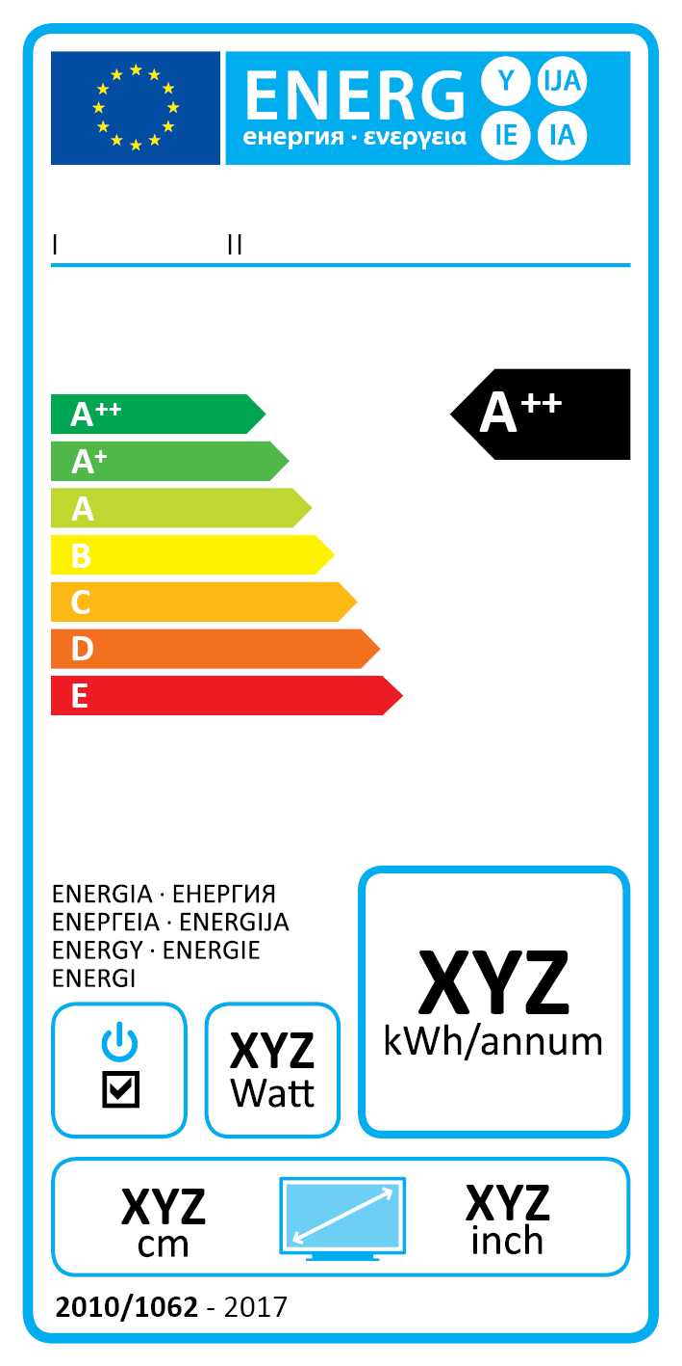  A++ to E label  From 01/01/2017 | 2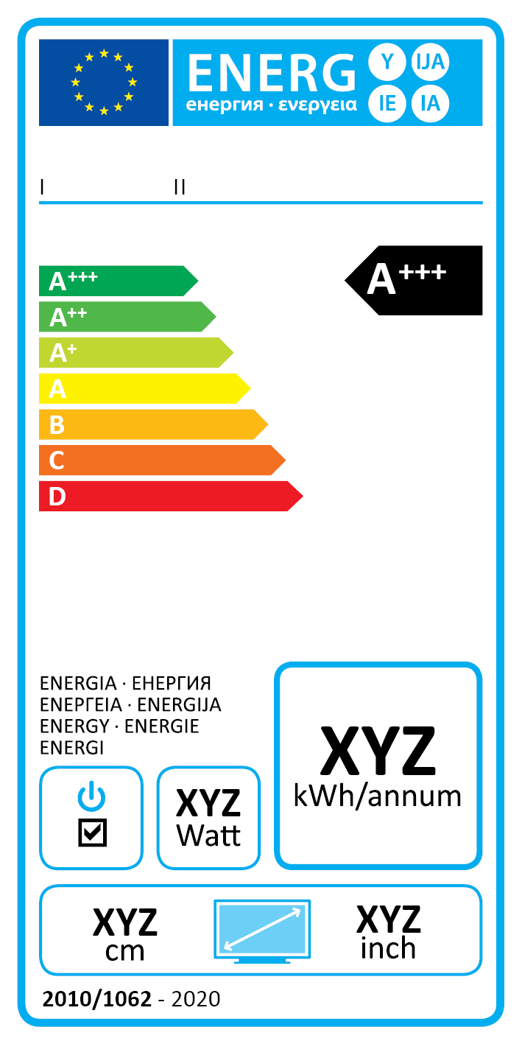  A+++ to D label  From 01/01/2020 |  | Commission Delegated Regulation nº 1062/2010
 |  |  | Energy efficiency class | Energy efficiency index
 |  |  | A+++ | EEI < 0,10
 |  |  | A++ | 0,10 ≤ EEI < 0,16
 |  |  | A+ | 0,16 ≤ EEI < 0,23
 |  |  | A | 0,23 ≤ EEI < 0,30
 |  |  | B | 0,30 ≤ EEI < 0,40
 |  |  | C | 0,40 ≤ EEI < 0,50
 |  |  | D | 0,50 ≤ EEI < 0,64

If a television set has an easy visible switch, which puts the device in a condition with power consumption not exceeding 0.01W then this symbol is added in the energy label.

EU Ecolabel
EU Ecolabel recognises products that have a lower environmental impact during their life cycle (raw materials extraction, production, use and disposal). The validity of criteria for the award of the EU Ecolabel to television sets, published in 2009, was recently prolonged until 31/12/2017. It guarantees lower energy consumption during use and standby and minimum energy efficiency class B.
This certification might be used as award/evaluation criteria and if so, X% (at least 10-15%) of the total marks available should be given to products certified by this certification.

To increase savings and reduce environmental impact, procurers should evaluate life cycle costs when tendering for computer monitors. Thus, it is advisable to include in the tender a costing exercise - even if simple - for the product life cycle costs.

Example of a breakdown costs table, to be filled in by bidders:
 | Information details | Different unit costs in € (excluding tax) | Total cost in € (excluding tax)
Delivery
Installation
Use* | On mode power (W) x nº daily hours in use x nº annual working days x 10 years x nº units | Electricity cost: 0,20 €/kWh**
Maintenance
Recycling and disposal
* Example of how use costs can be determined. The variables for the costs calculation during the product life time can be stated by the procurer (according to the equipment replacement rate, its daily and annual use, etc.).
** This figure is just an example. The procurer can use the average electricity price paid during the last 2 or 3 years, and also include subscription fee and taxes.

Advice and support
If you would like further assistance in using the information presented here in your own procurement actions or more information on Topten Pro please contact your national Topten team (find the links on Topten.eu).

The European Commission’s Green Public Procurement website also contains valuable legal and practical guidance together with procurement criteria for a range of commonly procured products and services.

