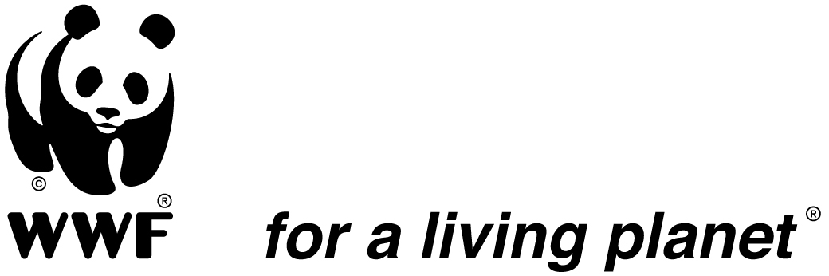

BRIEFING ON ENERGY LABEL DIRECTIVE RECAST
August 2009

Political process:

- Anni Podimata (socialist) and Claude Turmes (Greens) have been reelected as MEPs and they will lead the Energy Labelling dossier again, which will go through second reading at the Parliament.
- Commission and Parliament seem confident that the revision of the Labelling Directive can be finalised before the end of this year, especially with the support of the Swedish Presidency. So everything could be decided by the end of 2009.
- The European Parliament will reconvene on August 24 and the Energy Label is on the agenda for the ITRE committee meeting on Sept 2.
- The discussion between Parliament and Council are foreseen in October 2009.
- The Commission agreed to hold the implementing measure on the label for fridges & freezers until the situation is clarified. Legally speaking they can do it, but they cannot delay a decision for long, especially in case manufacturers start challenging the delay.
- Commission agreed to have a consumer survey whose results will be used to inform the discussion after the summer break.

Consumer Survey for the layout:

- The Commission (DG TREN) finally agreed to launch a consumer survey to test 2 options for the layout (A-G vs A -20%) and use the findings to get to a solution.
- Since the methodology used in the survey is an important aspect, stakeholders (MEPs, industry, NGOs) met to discuss the methodology. The survey should be completed by the end of the summer.
Several questions will be asked to the consumers to test various aspects of the labels (relevance of colours, letters, etc.)
- DG TREN still seems to stick to its idea of imposing an open-ended scale and they do not plan to respond to the NGO request to have an economic impact assessment as well, to counter-balance the claims from manufacturers regarding the economic losses they would incur if a closed A-G scale is kept.

Member States position:
- So far Netherlands and UK support NGOs recent position paper. France is looking for a quick way out. Germany and Italy are still vocal about rejecting any close-ended scale.

Attached: ENGO position paper (June 2009)

For further information please contact:
Mariangiola Fabbri (at WWF EPO) mfabbri@wwfepo.org

The sole responsibility for the content of this update lies with the authors. It does not necessarily reflect the opinion of the European Union. The European Commission is not responsible for any use that may be made of the information contained therein.



